بسم الله الرحمن الرحيم

King Saud University
College of Engineering
Civil Engineering Department

SE 423: “Digital Images Processing”
1444H 3rd Semester

Homework #9 Solutions

Q1: One type of data merging of images with ancillary data is by incorporating (data fusion) ancillary data with the image after they were accurately geo-coded so that they can be registered with the image data to a common geographic base. Is there a different way of doing that?
Answer;
Artificial Neural Network, (ANN), can be used directly to classify a digital image or as a combined with other classification methods like Pixel Based & Object Based classification methods.

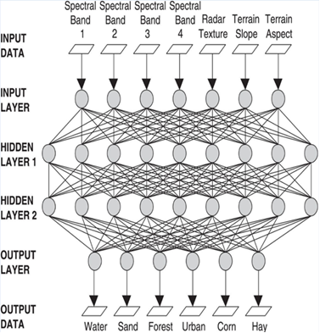

Each node in the input layer, in the ANN, is connected to one layer of data, (i.e. Blue band, green band, etc.). Therefore, we could introduce ancillary data one single ancillary data to a separate input node in addition to the input nodes for the image. This will be much easier & more convenient to deal with.

Q2: Explain briefly, how remote sensing biophysical modeling operations can be used in global warming. Give one Example.
Answer;
The goal of biophysical modeling operations is to relate quantitatively the remotely sensed data to bio-physical features & phenomena measured on the earth’s surface.
Remotely sensed data might be used in global warming in many ways. For example we could study the shrinkage in snow cover in the North or South poles over the years because of the warming in the atmosphere. For instance, we could take 5 satellite images of the same area near the North Pole over 12 years with 3-year separation time at the same date of the year & study the change in the snow coverage area as a measurement of global warming.

Q3: Explain briefly change detection procedures. Give at least one example to illustrate your answer.
Answer;
Change detection procedures can be summarized in the following 6 steps that are most likely to be involved in nearly all change detection procedures;
- Clear definition of the problem:
The first step is to define the change detection problem on hand & the type of remotely sensed data appropriate to the task.
- Acquire multi-date imagery:
Ideally, procedures should involve data acquired by similar sensors & be recorded using the same spectral resolutions, viewing geometry, radiometric resolutions & time of the day. Anniversary dates are preferred to minimize sun angle & seasonal differences. Registration to within ¼ to ½ pixels is generally required. Sensors operating in the visible & infrared portion of the spectrum are the most useful data sources for change detection analysis.
- Preprocess imagery both geometrically & radiometric:
The aim of these operations is to correct distorted or degraded image data to create a more faithful representation of the original scene.
- Apply change detection algorithm:
There are many methods of change detection, such as; post-classification comparisons, classification of multi-temporal data sets, temporal image ratioing, temporal image difference, & so on.
- Categorize change:
Transition materials, visual interpretation, etc.
- Report results.
For example, we could take 3 satellite images of the same area in a city over 10 years with 5-year separation time & study changes in the city as a measurement of urban sprawl.

